|  |  |
| --- | --- |
| **[Assignment / Project] – External Document** |  |
| <COMP6176>  <Human and Computer Interaction> |
| [Odd / Even / Compact] Semester Year 9999/9999 |

* **Project Title**

Store Del Luna

* **Introduction**

**Store Del Luna** is a famous 1st hand K-Pop merchandise supplier established in June 2013. We provide original K-Pop albums and merchandises from many artists.

With the growth of information technology, **Store Del Luna** plans to dive into the world of digital business. First, **Store Del Luna** must create a **logo** and **company** **website** that represents **Store Del Luna’s** image. With this website's existence, **Store Del Luna** hopes they can improve their service towards their customers. **Store Del Luna** entrusts you as a web designer to design and create their **logo** and **company** **website**.

* + - **dises Catalog**. You must create the **Navigation Menu** using **Drop Down Menu** using **CSS**. Below are the requirements for each page:
* **Home**

**Store Del Luna** wants this page to show about **their profile**. **Store Del Luna** also wants to have an **image-slider** using **JQuery animation** effect on this page to show their best seller **Artist’s Products**.

* **K-Pop Albums Catalog**

This page shows the K-Pop Albums. **Store Del Luna** wants the K-Pop albums needs to be categorized according to the artists, then show the product.

* **Merchandises Catalog**

This page shows the K-Pop Merchandises. **Store Del Luna** wants The Merchandises needs to be categorized according to the artists, then show theThe requirements from **Store Del Luna** are described below:

* + - **Store Del Luna** needs a **logo** that represents the image of a company that has **professional** and **cultural** principles. Consider the **customer segment**, **shape** and **colors** when designing the **logo**. The logo will be created using **Adobe** **Photoshop CC 2020**, ensure no layers are **merged**.
    - **Store Del Luna** wants you to design the **blueprint** of your **homepage** before making the HTML files. The **blueprint** will be created using **Adobe** **Photoshop CC 2020**. Ensure the **blueprint** that you created is the exact same with the website that you will make later. The **homepage blueprint** will contain **header**, **navigation**, **content,** and **footer** as its structure.
    - Wewant our website to provide **information** **about the store**, **K-Pop albums**, **Merchandises**, **and Customer Testimonials** and have **Registration** page to become a member.
    - **Store Del Luna** wants you to build the website attractive, appealing and fully functional, and also make sure the website is **responsive**. The website should be accessible using a mobile phone in a perfect way. To achieve that, use **5 kinds of CSS property** and **JavaScript**. Use **Meta** **viewport** **tag** and **media** **screen** **rule** that will be applied if the screen is **below** **600px** screen.

The website consists of five main pages. They are **Home**, **Testimonial**, **Register**, **K-Pop Albums Catalog**, and **Merchant** product.

* **Testimonial**

This page provides **testimonies** from **Store Del Luna’s** customers.

* **Register**

This page provides a **registration** menu for the customer. Customer needs to submit some personal information such as **username, password, confirmation password, full name, gender, email, age** and **customer must agree with terms and conditions**. You are also asked to create **5 kinds of form components** and **5 kinds of validation**. For validation, you must create it using **JavaScript** and **don’t use regular expression**

* **Report / Documentation**

1. 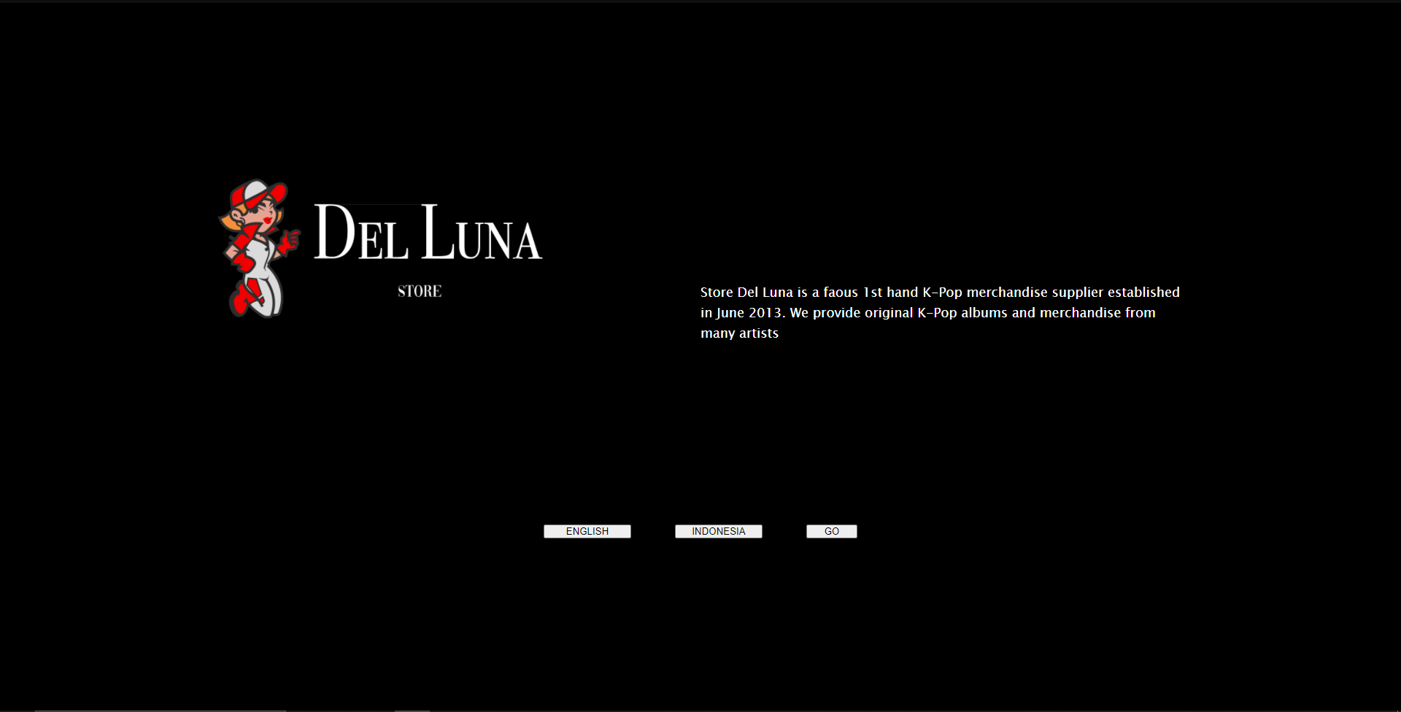  
   In the Welcome Page there are 3 buttons. Press the “go” button to go to Home Page
2. 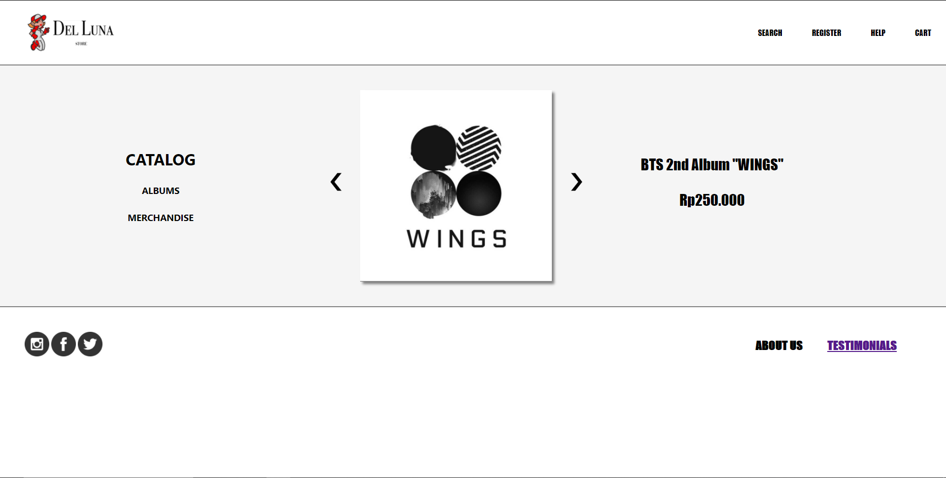  
   At the home page there are buttons that you press that can switch you through the Albums and Merchandise catalog. On the left side and right side of product images there are buttons that you can press to switch through to different products. And at the footer section there is button that will lead you to the Testimonial Page. And at the header section of our website there are a few buttons. The “REGISTER” button will lead you to registration page for the account.
3. 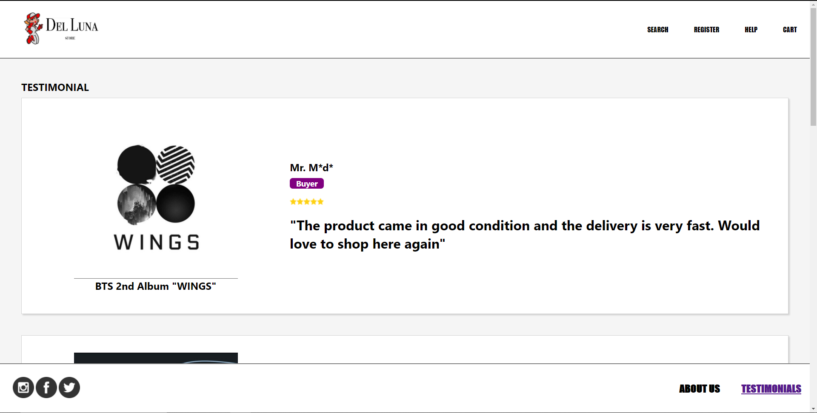  
   In the Testimonial Page you can see the feedback and review of the customer that have bought our product from our online store.
4. 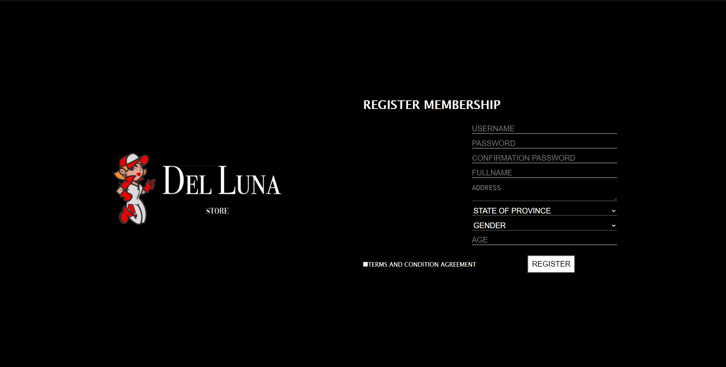  
   In the Register Page you can register by inputting all the required data.

* **Reference**
* Logo images: https://envato.com
* Social media icons: Adobe XD icons
* Product images: https://kpop-merchandise-online.com/
* **Group Member**
* <2301952230> – <Muhammad>
* <2301858042> – <Yohanes Raditya Wirawan Aruan>
* <2301940975> – <Jeremia Rayhan Samosir>
* <NIM> – <4th Student Name>